SIMATS ENGINEERING
ASSESSMENT TOOL 2

COURSE NAME: Cryptography and Network Security
COURSE CODE: CSA51
M.Rohith(192311184)

CONCEPT MAPS IN INFORMATION SECURITY
Steganography, Security Attacks, Threats, Risks and the CIA Security Goals

Introduction

Information security is not achieved by a single technique. It is created through a combination of methods that hide information, protect its ownership, preserve it against modification, recognize attacks, estimate their consequences and apply suitable controls. The two concept maps in this document explain these relationships in a connected and practical manner. The first map focuses on steganography and its major ideas—data hiding, watermarking and survivability. The second map follows the security chain from an attacker’s action to a threat, then to a risk, and finally to the confidentiality, integrity and availability controls used to reduce that risk.

Purpose of the Concept Maps
- Present complex security ideas in a clear visual flow instead of treating each term as an isolated definition.
- Show how one concept causes, supports or protects another concept.
- Connect theoretical principles with familiar real-world applications.
- Explain why confidentiality, integrity and availability must work together rather than independently.

Concept Map 1: Steganography | Concept Map 2: Security Attacks and CIA Goals
Explains how secret information can be hidden, authenticated and made strong enough to survive normal processing or deliberate attacks. | Explains how attacks create threats and risks, and how confidentiality, integrity and availability controls reduce their impact.
Overall idea: Secure communication requires secrecy, correctness, accessibility and resilience. A weakness in any one of these areas can expose the entire system.

- Concept Map: Steganography, Data Hiding, Watermarking and Survivability

Visual relationship: Steganography is the broad technique; data hiding and watermarking are major applications, while survivability measures the strength and persistence of the embedded information.
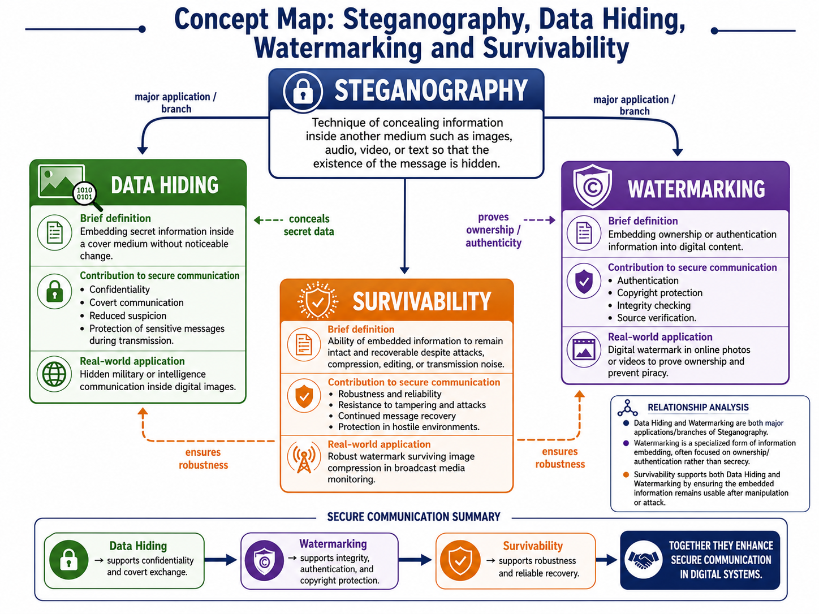
Flow: Cover medium + hidden information → embedding method → stego or watermarked content → transmission/storage → extraction or verification after normal processing or attack.
- Steganography and Data Hiding: Steganography is a security technique used to hide secret information inside an ordinary digital file such as an image, audio file, video or document. The main purpose is to conceal the existence of the communication itself. Data hiding is the broader process of embedding information into a cover medium without creating noticeable changes. For example, a confidential message can be hidden inside the pixels of an image and transmitted without attracting attention.

Role of Watermarking: Watermarking is closely related to data hiding, but its main purpose is to protect ownership, authenticity and copyright. A watermark may be visible or invisible and can contain details such as the creator’s name, company identity, serial number or ownership code. It helps identify the original source of digital content and detect unauthorized copying or modification. For example, photographers and media organizations use invisible watermarks to prove ownership of images shared online.

Importance of Survivability: Survivability refers to the ability of hidden or watermarked information to remain detectable and recoverable even after the digital file is compressed, resized, cropped, filtered, converted or deliberately attacked. A strong embedding technique should preserve the hidden information during normal use and common processing operations. Survivability improves the reliability of steganography and watermarking by ensuring that security information is not easily destroyed.

Contribution to Secure Communication: Steganography, data hiding, watermarking and survivability work together to provide confidentiality, authenticity, ownership protection and resilience. Steganography conceals the secret message, watermarking verifies the source or owner, and survivability ensures that the embedded information remains useful over time. Together, these techniques are applied in military communication, medical records, digital media protection, copyright enforcement and secure document sharing.

2.Explanation and Analysis of the Steganography Concept Map

2.1 Steganography as the Central Concept
Steganography is the practice of concealing the existence of a message inside an ordinary digital object such as an image, audio file, video, text document or network packet. Unlike encryption, which makes the content unreadable but still reveals that a protected message exists, steganography attempts to make communication appear normal. The central objective is therefore covert communication. Encryption and steganography can also be combined: encryption protects the meaning of the message, while steganography hides its presence.

2.2 Data Hiding
Relationship: Data hiding is a direct branch of steganography. Secret bits are embedded into less noticeable portions of the cover medium, such as the least significant bits of image pixels or selected audio samples.
Contribution to secure communication: It improves confidentiality by reducing the chance that an outsider notices a sensitive exchange. It is especially useful where the discovery of communication itself may create danger. However, data hiding alone does not guarantee that the hidden message cannot be read after detection; therefore, encryption should be used for highly sensitive data.
Real-world application: A military or intelligence unit can embed short location coordinates or authentication codes inside an ordinary field photograph. The image can be transmitted through a normal channel without visibly exposing the secret message.

2.3 Digital Watermarking
Relationship: Watermarking also embeds information into digital content, but its purpose is usually ownership, authentication, traceability or integrity rather than complete secrecy. A watermark may be visible, such as a logo, or invisible and detectable only by software.
Contribution to secure communication: It supports integrity and authentication by showing who created or distributed the content and whether the content was altered. Transaction-specific watermarks can also identify the source of an illegal copy, discouraging unauthorized redistribution.
Real-world application: Streaming platforms can insert an invisible subscriber-specific watermark into a movie. When an illegal copy appears online, the provider can examine the watermark and trace the source account without visibly affecting the viewing experience.

2.4 Survivability
Relationship: Survivability is the ability of hidden or watermarked information to remain detectable and recoverable after compression, resizing, cropping, filtering, format conversion, noise or intentional tampering. It therefore supports both data hiding and watermarking by measuring robustness.
Contribution to secure communication: A survivable embedding method ensures that evidence, authentication data or a concealed message is not destroyed by routine processing. This increases reliability and preserves security information throughout the communication life cycle.
Real-world application: News agencies can place robust invisible watermarks in photographs. Even after the image is compressed for a website or resized for social media, the watermark can still prove the original source.
Importance in hostile environments: Survivability becomes especially important when digital content travels through untrusted networks or is processed by different devices and applications. A strong steganographic or watermarking technique should continue to protect the embedded information even when attackers try to remove, distort or overwrite it.
Role in authenticity and ownership protection: Survivability helps maintain long-term proof of ownership and authenticity. When a watermark remains intact after editing or redistribution, organizations can verify the content source, detect unauthorized changes and provide evidence in copyright or legal disputes.
Support for long-term security: Survivability ensures that embedded information remains useful even when digital files are stored, shared and modified over long periods. This is valuable for archived documents, medical images, legal evidence and multimedia records because the hidden authentication details can still be recovered later to verify originality, ownership and integrity.
Combined security value: Data hiding provides secrecy, watermarking provides ownership and integrity evidence, and survivability ensures that the embedded information continues to serve its purpose after processing or attack.

3.Concept Map: Security Attacks, Threats, Risks and Security Goals

Visual relationship: An attack is an action performed by an adversary. It creates a threat, the threat may produce a risk or loss, and security goals guide the controls used to reduce that loss.
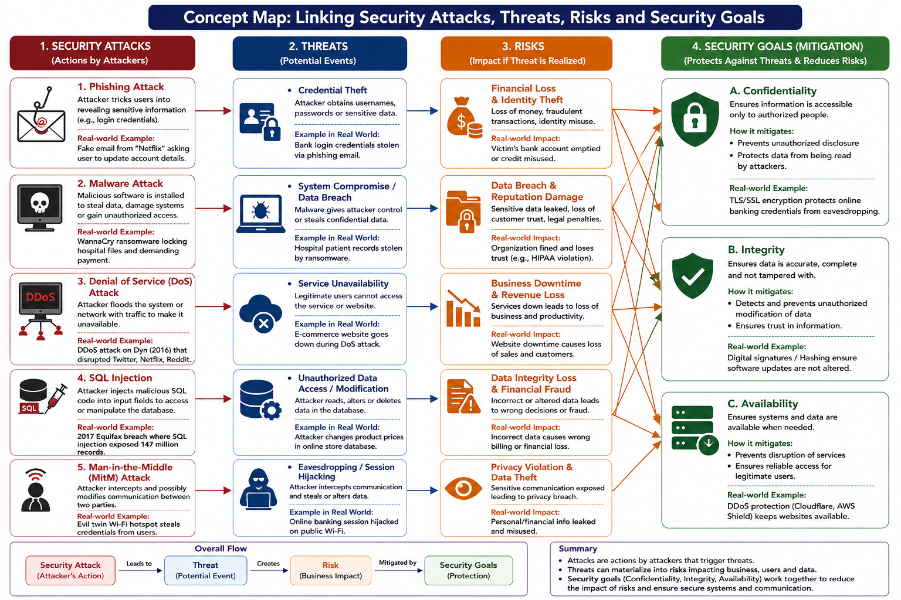
Core chain: Attack → Threat → Risk → Security control based on Confidentiality, Integrity or Availability.

Attack | Threat created | Main risk | Security goal | Real-world link and mitigation
Phishing | Credential theft and impersonation | Financial loss, identity theft and privacy loss | Confidentiality + Integrity | A fake bank email captures a password. Multi-factor authentication, encrypted sessions and login verification reduce unauthorized access and fraudulent modification.
Malware / ransomware | System compromise, data theft or file encryption | Data breach, downtime, recovery cost and reputational damage | Confidentiality + Integrity + Availability | Ransomware encrypts hospital records. Endpoint protection, least privilege, offline backups and recovery testing keep information private, accurate and available.
Denial of Service | Service unavailability | Business interruption, lost revenue and customer dissatisfaction | Availability | A botnet floods an e-commerce site during a sale. Traffic filtering, rate limiting, content delivery networks and redundant servers maintain access for legitimate users.
SQL injection | Unauthorized reading, alteration or deletion of database records | Privacy breach, incorrect decisions, fraud and compliance penalties | Confidentiality + Integrity | An attacker changes product prices through an unsafe input field. Parameterized queries, input validation and restricted database permissions block unauthorized access and modification.
Man-in-the-Middle | Eavesdropping, message alteration or session hijacking | Privacy violation, stolen credentials and fraudulent transactions | Confidentiality + Integrity | A malicious public Wi-Fi hotspot intercepts login traffic. TLS encryption, certificate validation and secure VPN use prevent reading or changing data in transit.

How the CIA Goals Work Together
The three main security goals—Confidentiality, Integrity and Availability—work together to provide complete protection for information and systems. Confidentiality ensures that sensitive data is accessed only by authorized users. It is commonly achieved through encryption, passwords, multi-factor authentication, access control and proper user permissions. These methods reduce the possibility of information being exposed, stolen or viewed by unauthorized people.
Integrity ensures that information remains accurate, complete and unchanged during storage, processing and transmission. It protects data from unauthorized modification, accidental errors and malicious manipulation. Techniques such as cryptographic hashes, digital signatures, validation checks, audit logs and controlled access help verify that the data received is the same as the data originally created or sent.
Availability ensures that information, applications and network services remain accessible whenever authorized users need them. It is maintained through backups, redundant servers, monitoring tools, load balancing, capacity planning and disaster recovery procedures. These controls help organizations continue operating during hardware failures, cyberattacks, natural disasters or unexpected system interruptions.
In practice, these three goals cannot be treated separately because most cyberattacks affect more than one area. For example, ransomware can make files unavailable by encrypting them, damage integrity by modifying data and also threaten confidentiality if attackers steal information before encryption. Similarly, a compromised user account may expose private information, allow unauthorized changes and interrupt normal services. Therefore, strong security systems use multiple layers of protection that support confidentiality, integrity and availability at the same time.

Conclusion
The two concept maps show that secure communication depends on both protective techniques and risk-aware controls. Steganography hides the existence of communication, watermarking establishes authenticity and ownership, and survivability keeps embedded information useful after modification. At the system level, attacks create threats, threats produce risks, and the CIA goals guide the controls that reduce those risks. Security becomes effective when secrecy, trustworthiness, accessibility and resilience are designed together rather than treated as separate activities.

